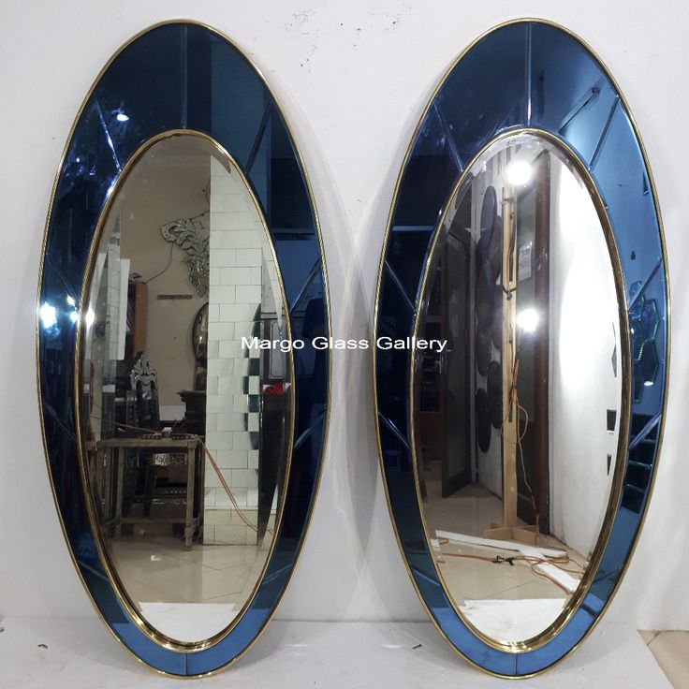***Graceful Curves with Timeless Oval Mirrors***

In a world full of sharp edges, **Oval Mirrors** bring a soft and sophisticated alternative. Their elongated, curved shape adds a touch of elegance and fluidity to any space, making them ideal for those who seek harmony in design. Oval mirrors gently break the rigidity of rectangular rooms, offering a subtle statement that is both classic and contemporary.

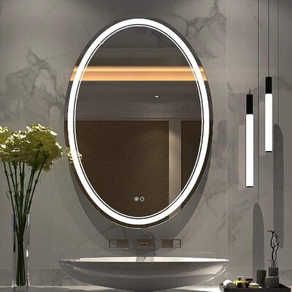Our Oval Mirrors are available in a wide range of finishes — from sleek metallic frames to vintage-inspired bronze and clean frameless designs. Each mirror is crafted using high-quality, distortion-free glass to provide a crystal-clear reflection and lasting durability. Their graceful form complements a variety of spaces, whether placed above a vanity, console, or in a hallway to draw the eye.

These mirrors help enhance natural light, create the illusion of space, and introduce visual movement to static walls. Their soft silhouette makes them a popular choice in both modern and traditional interiors, blending easily with bohemian, transitional, or minimalist décor styles.

Add elegance, warmth, and visual flow to your home with an oval mirror that reflects more than just your image — it reflects your refined taste.